The National Faculty Development Program: Considering Diversity, Equity, and Inclusion

Abstract:
The National Academy of Higher Education at the Higher Education Commission of Pakistan conducted a faculty development program for over 500 new PhDs prior to their placement at universities. Initially envisaged as a residential, face-to-face program, the National Faculty Development Program 2020 had to pivot to a remote, online format due to the COVID-19 pandemic and lockdown. In this paper, four instructors and an administrator of the program discuss how inclusivity and equity were built into the design and delivery of this program at all stages. The paper begins with an overview and background of the program, followed by reflections on the Universal Design for Learning, active learning, engagement beyond ‘the classroom’, and the use of skill-building clinics for inclusive practices in English language development. It concludes with a discussion and some questions for further study. The authors conclude that the program built capacity for online as well as in-person delivery to support adaptability, flexibility, empathy, confidence, and the possibility of incorporating inclusive practices. An attempt is made in the paper to retain the distinctive authorial voices of the contributors, in order to support the cultural, geographical, disciplinary, experiential and other diversity in the team.
Keywords: Higher education, faculty development, online, inclusive, instruction.

Introduction
The Higher Education Commission (HEC) of Pakistan launched the Interim Placement of Fresh PhDs (IPFP) Program in 2009 to provide employment to selected new PhDs as Assistant Professors in Pakistani universities for a year. As of April 2019, about 75 per cent of 4,337 IPFP Fellows went on to be hired as permanent faculty at their respective universities. The fact that the remainder had not been retained at their institutions led to a revised policy in which the HEC mandated that IPFP candidates would be required to receive training prior to their year’s placement.
The National Academy of Higher Education (NAHE) was launched in June 2019 and tasked with the design and delivery of this faculty development program. A newly established NAHE also saw this as an opportunity to incorporate essential knowledge and skills to enhance equity and inclusion in classrooms, in line with its mission. This led to the development of the National Faculty Development Program 2020 (NFDP-2020) to synergistically address both needs.
This paper presents reflections of the NFDP-2020 administrators and instructors in order to share ways in which equity and inclusion was incorporated into NFDP-2020 in two dimensions:
(1) to enhance the achievement of all learning outcomes
(2) to enhance learning of ways to promote equity and inclusion in participants’ classrooms.
Crucially, a shared focus on in-person and online instruction aimed to help those that completed the program to be adaptable to a relatively unknown post-COVID era to meet the needs for instructional delivery, given future constraints and challenges.
NFDP-2020 was designed to “practice what we preach” related to equity and inclusion, and our reflections highlight examples related to the administrative planning, instructional design, and delivery of teaching aspects of NFDP-2020. The next section presents a brief overview of the NFDP-2020, followed by examples of intentionally incorporating learning of equity and inclusion. The paper concludes with a brief discussion and recommendations.

National Faculty Development Program 2020
NAHE initiated its response to the need to conduct a faculty development program for approximately 600 recent PhDs seeking placement at universities across Pakistan in November 2019. The process began with a pre-assessment to gauge participants’ understanding across three broad areas: teaching effectiveness, research, and academic leadership. This 180-minute assessment was designed to be as general as possible, given that candidates represented a wide range of disciplinary specialisms. A combination of multiple choice, short answer and essay questions covered elements of these areas and included topics like academic honesty, grant-writing, candidates’ teaching philosophies and research plans. It was conducted on January 26, 2020 across five HEC regional centers.
The results suggested a number of gaps including written communication, analytical skills, challenges, and determinants of good teaching, as well as the absence of a clear research plan or vision. Based on this understanding, the NFDP-2020 started to take shape with me, Sara Zubair, as its focal person at NAHE, under the stewardship of the Rector, Professor Shaheen Sardar Ali. Dr Steven Burian took the helm for design and delivery: NFDP was envisaged as an intensive, one-month residential program to be held concurrently at HEC regional centers and certain universities across Pakistan.
While discussion was underway about just how many times, we would need to run the program to accommodate the sheer number of candidates – 540 after pre-assessment – Pakistan went into lockdown at the end of March 2020 due to the rapid spread of COVID-19. What did this mean for the NFDP?
First, everything had to pivot to a fully online mode of delivery. This not only meant rethinking content, e.g. doing away with a separate module on ‘technology in education’ and drawing attention to technology throughout the program, but also redesigning what a day would look like when it was virtual. Second, NAHE had to fulfil all HEC requirements to ensure it was “online ready” as an organization. Third, suddenly the most difficult operational questions we had confronted now had answers: how would we accommodate such large numbers of participants? How could we keep track of so many concurrent workshops to ensure consistent and sustained quality? Who was going to deliver all these workshops?
The first two of these answered themselves the moment NFDP-2020 went online; for its online iteration, Dr Steve Burian and Dr Shazia Awan led the instructional team, which included Dr Saima Sherazi, and Dr Hassaan Khan. The instructors joined the program from the United States, Canada, United Kingdom and Pakistan, respectively. Four cohorts were planned, starting with a cohort of about 40 participants or Fellows, and the remaining three with 100-150 Fellows each.
A typical day in the 24-day program was as follows:
Table 1. Daily Schedule
Time (PST) | Activity | Interaction Method
8:00-10:00 am | Live Interactive Webinar and Learning Activities | Synchronous
10:00-10:30 am | Break
10:30-12:30 pm | Reading Boot Camp | Synchronous
12:30-1:30 pm | Lunch Break
1:30-3:30 pm | Writing Boot Camp* | Synchronous/Asynchronous
3:30-4:00 pm | Break
4:00-6:00 pm | Labs, Juries, Panels* | Synchronous/Asynchronous
After 6:00 pm | Additional Work Time, Mentoring & Coaching | Synchronous

The following graphs are a snapshot of the diversity inherent among NFDP-2020 Fellows across gender, domicile, country, and discipline of PhD earned.
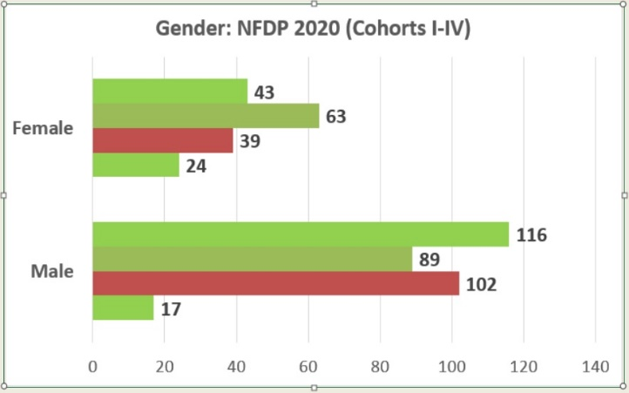
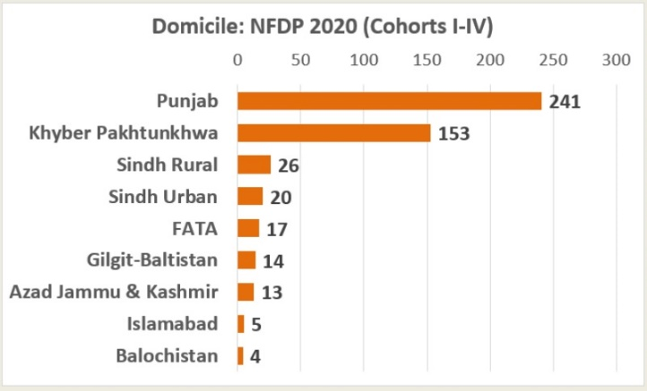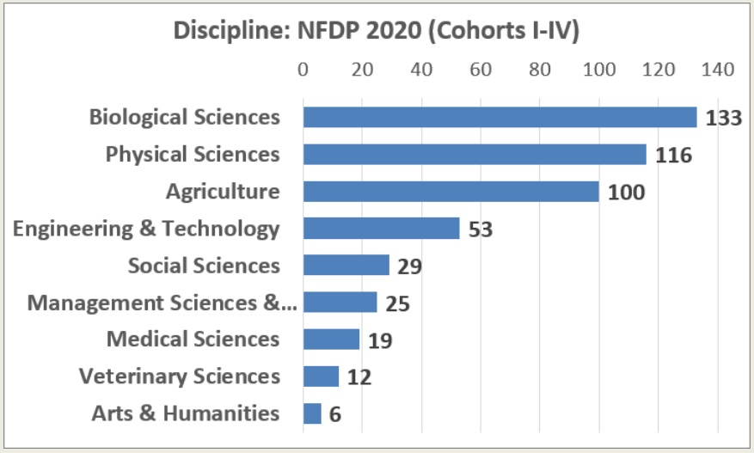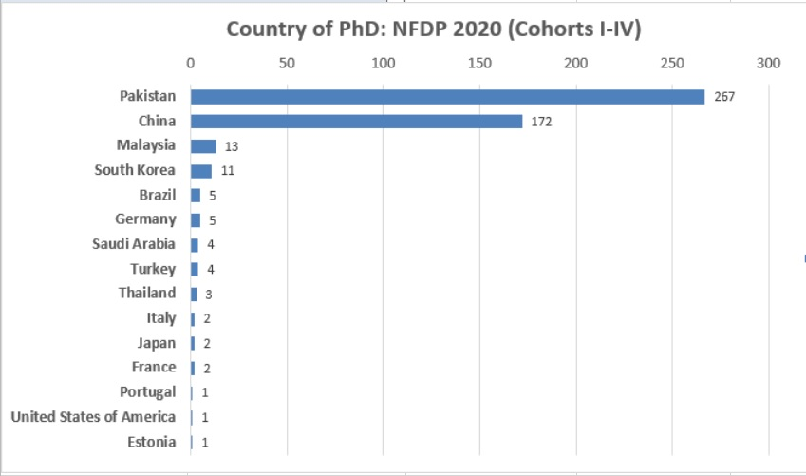
To maintain an emphasis on equity and inclusivity throughout the process, not only because of the diversity reflected in the program, but also with Fellows’ varying levels of interest, engagement, ability, and accessibility – particularly at a time when the world was confronted with a pandemic and its unsettling effects – was challenging to say the least. However, in the sections that follow, each instructor will share their reflections on an element of the program to create a sense of how diversity, equity, and inclusion were woven into instructional design and delivery.

Approaches to Promote Equity and Inclusion in NFDP-2020 and Fellow Capacities
The first subsection is Dr Shazia Awan’s reflections on how Universal Design for Learning was incorporated in the design and instruction of the program. This is followed by Dr Steven Burian’s discussion on the lesser-known benefit of active learning for equitable and inclusive classrooms. Dr Hassaan Khan’s focus is on student engagement beyond seminars and structured activities, by sharing how the online environment was also able to lend itself to the concept of ‘outside the classroom’. Finally, Dr Saima Sherazi reflects on ways in which a focus on English, particularly writing for academic purposes, supported the program’s emphasis on inclusivity. We have made a deliberate attempt to maintain each contributor’s authorial voice to echo how diversity in the administrative and instructional team supported the program’s emphasis on inclusivity and equity without aiming to homogenize individual strengths and attributes.

Universal Design for Learning
Course design, use of online educational tools, development of resources, pedagogical principles, institutional support, and student support and monitoring involve careful thinking and planning, particularly for online teaching and learning (Rapanta et al, 2020). One design practice that has been used to make courses more inclusive and accessible in the digital environment is Universal Design for Learning (UDL). UDL is a scientifically developed pedagogical framework that was originally introduced to consider integration of inclusive practices for students with special needs. Since the 1960s, UDL has evolved into a framework that helps create an inclusive environment for all students and helps “improve and optimize teaching and learning for all people based on scientific insights into how humans learn” (CAST, 2018).
NFDP-2020 followed UDL guidelines using three frameworks: the Universal Design for Learning (UDL), the Universal Instructional Design (UID) and Universal Design of Instruction (UDI). These informed the design for learning, instructional design of the online course on Moodle (the selected Learning Management System for the program), and design for virtual classroom instruction in both synchronous and asynchronous formats.
A deliberate effort was made by the instructional team to create an inclusive, accessible, and equitable online learning experience. Course offerings were made in more than one format that provided multiple means of representation (Fig. 1, Green section); for example, synchronous lessons, interaction with the course material, instructors, and peers both synchronously and asynchronously. UDL also informed multiple ways to motivate students to learn through multiple means of engagement (Fig.1, Purple section). Some of these were office hours, peer and mentor support, and synchronous participation on Google docs. Careful deliberation also ensured learners know, are able to, and value learning through multiple means of action and expression; for example, short quizzes during synchronous lessons, module quizzes on Moodle, individual assignments, team and group assignments in both written and spoken formats.
While participants attended the program from Pakistan, and the timetable ran according to the Pakistan Standard Time, instructors joined from Atlantic Standard Time (NS, Canada), Mountain Standard Time (Utah, USA), GMT and Pakistan Standard Time. The course was designed with some inherent flexibility for time for this reason, as well as to be inclusive and accessible for learners, such as making adjustments to the schedule during the month of Ramadan. This was challenging due to the length of the course itself.
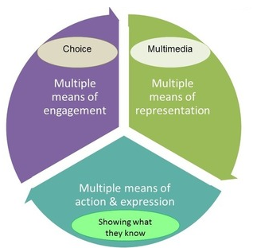
Five principles of universal instructional design were adhered to: (i) accessibility to the content before, during, and after the course (ii) consistency in presentation of the content (iii) flexibility in the use, participation and presentation of the LMS (Moodle) and other platforms such as Microsoft Teams and SharePoint (iv) provision of a supportive and intuitive learning environment through pre-course orientation to the online environment, and (v) an online learning space that accommodates both participating Fellows and instructional methods.
Figure 1: UDL as it was used for NFDP2020 course design optimized the teaching & learning by giving more choices throughout the process (Image by Sebouh J. Serabian)
For course delivery, Universal Design of Instruction (UDI) was kept in mind. The lead instructional team planned carefully to accommodate the number of Fellows taking the course, which was up to 150 Fellows at one time. A purposeful effort was made to deliver the course to ensure Fellows had a successful learning experience, and a ‘growth mindset’ was adopted. According to Taylor et al (2019, p. 133) “a syllabus that signals belongingness, growth mindset, communal goals, clear and positive expectations, and success-orientation assists in setting a welcoming tone that leads to greater student achievement and engagement”. Instruction that is focused on growth mindset as opposed to a fixed mindset is success oriented.
To achieve success-oriented objectives for classroom instruction and execution of the syllabus, the following four principles were observed for synchronous, asynchronous, and collaborative environments of the digital space: (i) equal and flexible use of content and instruction (ii) simple, intuitive, and perceptible information and interaction, (iii) tolerance for error, and (iv) effort to create a community of learners through the instructional climate.
The next sub-section hones in on the benefits of active learning and how it was understood and incorporated in NFDP-2020.

Active Learning
Active learning is a proven pedagogical approach to engage students in their learning process. Delivering active learning exercises requires the teacher to (a) provide a meaningful learning activity, (b) stimulate critical thinking, and (c) guide a student reflection on their learning. The intentional use of active learning spans more than three decades, with the past two providing extensive research evidence of its effectiveness.
Figure 2 illustrates the kinds of benefits active learning offers. Most notably, active learning helps students achieve learning objectives. Further, active learning builds student success skills (e.g., communication, teamwork) and increases teacher engagement and enjoyment of teaching. A lesser-known benefit is that active learning also enhances equity and inclusion.
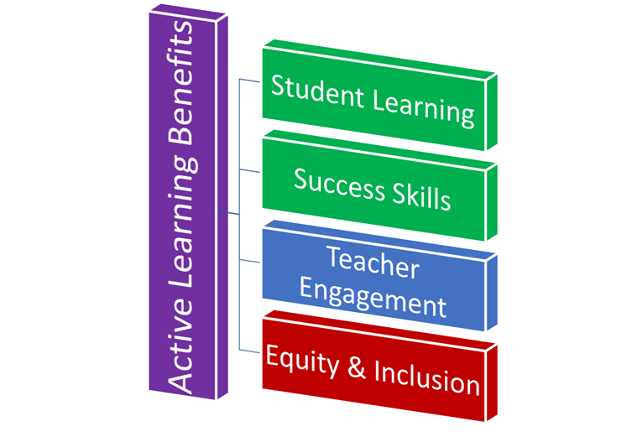
Figure 2. Active learning benefits the students (green shaded), teacher (blue), and classroom (red).
The literature is replete with scholarly work from educational psychology and learning science supporting the effectiveness of active learning for enhancing student learning compared to more passive techniques (e.g., Prince 2004; Michael 2006). Deslauriers et al. (2019) reinforced these previous findings with documented evidence of actual learning, in addition to students’ perceived learning (Lumpkin et al. 2015). Importantly, active learning provides transferable skills, hones subject matter expertise, and builds self-reliance and independent learning capacity in students (Agarwal 2019), which aided the design and execution of NFDP-2020
Less well known about active learning are the benefits for promoting equity and inclusion. Active learning helps underrepresented students in science, technology, engineering, and math (STEM) narrow the achievement gap (Lorenzo et al. 2006; Haak et al. 2011; Theobald et al. 2020). Although beneficial in many respects, a recent study noted the greater participation of men in voluntary responses after small-group discussions suggesting a need for instructors to facilitate active learning in intentional ways to increase inclusive and equitable participation by all students (Aguillon et al. 2020). This understanding influenced the way the instructor team approached NFDP-2020 program development and delivery
Because of the many benefits of active learning, the efficacy of the strategy for building teacher competencies (Virtanen et al. 2017), and the potential to support inclusion and equity, the instructor team adopted active learning for NFDP-2020. The team considered active learning pedagogy comprehensively – in planning, designing, and delivering NFDP-2020. Because of the shift to emergency online teaching, the instructors adapted the active learning pedagogy and activities to the online classroom environment of NFDP-2020. Transitioning to online challenged the use of active learning, leading the instructional team to carefully consider and incorporate the use of online collaborative tools, provide explicit directions for reflection, and train Assistant Mentors to help facilitate group activities.
With NFPD-2020 being a faculty development program for new professors, the use of active learning addressed three broad goals. First, and foremost, active learning as a pedagogy helped NFDP Fellows achieve the program learning outcomes. Second, by providing numerous active learning examples, NFDP Fellows benefitted as teachers in training. And third, stressing equity and inclusion, active learning supported the program goal of promoting participation and success of underrepresented groups while providing opportunities for NFDP Fellows to be exposed to additional examples of ways to enhance equity and inclusion in their classrooms and academic life.
With these goals in mind, NFDP incorporated numerous active learning techniques (see Figure 3 for examples organized into categories). Some exercises required adaptation for an online environment or needed the use of web-based educational technologies (e.g., Kahoot, Mentimeter, PollEverywhere). Microsoft Teams and collaboration tools (e.g., Google Doc, Perusall) facilitated formal and informal cooperative exercises.

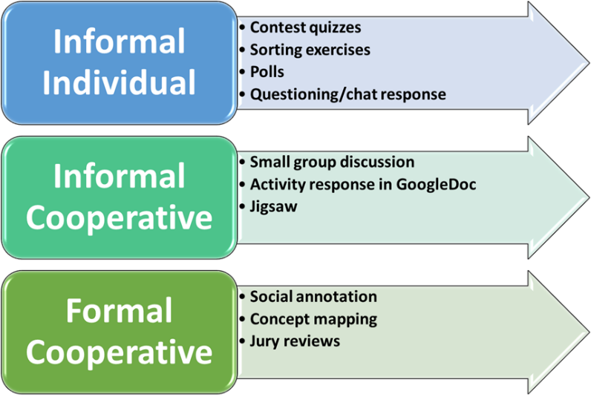
Figure 3. Active learning techniques used in NFDP-2020.
Active learning helped enhance equity and inclusion in NFDP-2020, and helped Fellows build capacity for enhancing equity and inclusion in their future classrooms. Administratively, the incorporation of interactive and social elements provided a way to track participation and quality of participation for assessment purposes. In design, NFDP-2020 employed active learning, adopted technologies to support active learning (e.g., Perusall), and included a module focused on improving capacity of Fellows for adopting active learning in their classrooms. In delivery, one example is a Reading Boot Camp session that included social reading, small group discussion, and a summary written report.
The assignment required Fellows to find, and reference, additional research-based sources of evidence of benefits of active learning for equity and inclusion to complement the assigned reading (Brame 2016). This activity introduced Fellows to the concept of how learning activities can be designed to enhance learning and to help achieve other outcomes, which was how we used the activity. Throughout planning, designing, and executing NFDP-2020, the instructors found ways to use active learning to support the learning objectives and to enhance participation and success of underrepresented groups.
Reflecting on NFDP-2020, the use of active learning seemed to have increased engagement of Fellows. Unsolicited feedback from Fellows noted repeatedly the enthusiasm for the interactive features during seminars, the use of Perusall for social annotation, the building of relationships during the teamwork, and more. The effectiveness of active learning for promoting equity and inclusion in NFDP-2020 was less clear. There was no indicator of achieving this objective other than the one noted. The instructional team anticipated seeing stronger participation of females and this was observed in chat and in office hours. However, the translation of this to encourage Fellows to apply active learning to achieve equity and inclusion objectives at their institution remains to be observed in the future.
From offering NFDP-2020 online and with a large cohort (50-200 participants), we learned the importance of providing extra structure and clarity for active learning exercises. We also adapted ways to reinforce instructional content using office hours and other engagements to help Fellows view their teaching approach through a lens of equity and inclusion. The next sub-section describes the NFDP-2020 approaches to engaging Fellows in an online setting.

Engagement ‘Outside’ the Online Classroom
Training new faculty members to be effective teachers and researchers is fraught with several difficulties (Brownell and Tanner 2012). Doing so in an online setting amidst a pandemic introduced additional challenges, foremost of which were student engagement and developing community.
A significant body of research shows the importance of focused interaction between instructor and students in improving learning outcomes (Bjorklund et al. 2004; Lundberg and Schreiner 2004). For the NFDP, the large cohort size meant that it was not possible to respond to each Fellow’s query during the daily webinar. As each cohort had been subdivided into sections, with each section led by an instructor and supported by Assistant Mentors, to fill this gap, a separate office hour was conducted daily for each section of the cohort.
Unlike typical office hour sessions, instructors were actively involved in developing a (loose) agenda for the session; these sessions can alternatively be categorized as daily mentoring sessions which were more supportive of equity and inclusion than the standard office hour model of ‘come as you are and ask questions’. The primary goal for the office hour was to provide an opportunity to Fellows to ask any unanswered questions from the webinar, and to solicit feedback on the day’s activities. The office hour was held after the end of the scheduled activities for the day, and attendance was voluntary.
On average, between 50-70% of Fellows attended the office hour sessions on any given day. This number was consistent across cohorts, although some variation across sections and cohorts were observed. Those that attended the office hour were usually present from start to finish. In addition to the stated primary goal, the office hour provided an opportunity to Fellows to practice public speaking in English. Multiple fellows identified this as a key benefit of the entire training. Fellows would occasionally air grievances regarding other group members or bring up issues related to interpersonal conflicts. These office hours thus also served as a forum for instructors to model inclusivity and demonstrate conflict resolution approaches that Fellows could employ in their future careers. With each cohort comprising Fellows who completed their doctoral work in various countries and academic systems across the world, the office hour allowed for exchange of ideas and perspectives regarding pedagogical approaches.
To encourage Fellows to attend and participate actively in the office hour, efforts were made to involve them in logistics, which educational literature suggests can improve effectiveness of office hours (Griffin et al. 2014). The timings for the office hour were decided through a poll at the start of the Cohort, ensuring that a time-slot convenient for most was selected; this was especially important for female Fellows. Fellows were not forced to participate; the more introverted ones preferred to observe silently on the sidelines. To help cement behaviors early on in the Cohort, the first few office hours contained important information and were advertised more actively to improve attendance (Guerrero and Rod 2013). Adopting these approaches and contextualizing them allowed for the office hours to become an integral part of the training program.
Strong professional networks play an important role in early career success for faculty members, more so for women and underrepresented minorities (Ansmann et al. 2014; Yun et al. 2016). One of the goals for this Program was to provide opportunities for early career academics to build professional networks. This was especially important for Fellows who had completed their doctoral training outside of Pakistan. Each Fellow had been assigned a group using a methodology that attempted to maximize diversity and interdisciplinarity, and most activities in the Program were group-based. Thus, the strongest network developed by each Fellow was that of their assigned group members, with whom they interacted for several hours a day for an entire month, and their self-selected Research Team, with whom they collaborated on the Research Practice modules.
To allow for building connections beyond these groups, weekly ‘socials’ were organized where Fellows would be able to interact with peers in their Section. The goal for the Socials was to engage Fellows in fun activities as they networked with a larger pool of Fellows. The NFDP period overlapped with the time when many parts of the country were under a lockdown due to COVID-19. In this context, these weekly socials also provided Fellows with an opportunity for social engagement. Thus, while participation was voluntary, these socials would be well attended (around 70-80% attendance).
Held on a Saturday evening, the socials comprised icebreakers, talent shows, and gameshows. These activities helped Fellows further hone their social skills in an online setting and express themselves beyond the confines of an academic setting. In the exit surveys conducted, most Fellows indicated that Socials were useful in helping them expand their new academic networks. An interesting follow-up would be to study how many of these academic networks are sustained once the training period has ended (Wolff and Moser 2009).
The following section focuses on how NFDP-2020 aimed for inclusivity through building competency in English using skill-building clinics.

Developing Global Competencies: Inclusivity through Communication in English
This section discusses the role of skill-building clinics in developing competencies in English for inclusivity through decolonizing of English for Academic Purpose (EAP) for social justice. The pre-assessment had revealed worrisome deficiencies in reading and writing in English and Fellows appeared to have little or no explicit awareness of research writing conventions and academic style. Their tacit understanding of writing and publishing conventions was through copying and writing with supervisors but not any direct instruction in EAP.
According to Keaton (2015), a focus on academic professionalism throughout a study term can “help students develop the skills, attitudes, and behaviors they need to chart successful courses as students and soon-to-be professionals”. Taking a Critical EAP and academic literacies (AcLits) approach that sees literacy development as part of social practice allowed us to engage Fellows’ diverse cultural backgrounds and identities to engender academic professionalism. To emphasize the all-pervasive presence of English language competencies and for greater affective engagement training and socialization with EAP, it was embedded within the various modules of the program.
Fellows also learnt the epistemological codes of practice and the ‘semantic waves’ of meaning-making in their disciplines by being completely immersed in their disciplines while undertaking their doctoral research, without having conscious and explicit knowledge of how knowledge is created through writing in their discipline (Coffin & Donhue,2014). Most second language learners, because of this lack of explicit knowledge of structures, exhibit the tendency to copy rather than paraphrase that creates plagiarism issues.
In engendering disciplinary awareness, the ‘academic socialization’ model is the most prevalent in higher education institutions (HEIs). Implicit learning in academic socialization “functions as the institutional default model: students will ‘pick up’ writing as a part of their studies without any specific teaching or practice” (Lillis, 2006: 32). Prolonged exposure to the academic literacy practices of a discipline helps students to learn to write ‘with time’. On the other hand, in the explicit more direct approach, students are taught features of specific academic genres ‘specific clusters of linguistics features’ are taught (Lillis, 2006: 31). According to Lea and Street, there are ‘deep language, literacy and discourse issues involved in the institutional production and representation of meaning’ (1998: 159) which may confuse students leaving them to discover for themselves the variation and diversity that exists in how knowledge and meaning is constructed through writing. The NFDP-2020 skill building clinics laid the foundations for this awareness.
An essential re-training in academic skills in English was attempted. We tried to blend the best of EAP with academic literacies (Tribble & Wingate, 2012) for socialization with the professional practice skills of expressing themselves in speech in micro-teaching, Pecha Kucha, the three-minute thesis (3MT) concept and in class and group participation during group work and in office hours. Online interaction tools and synchronous team meetings played a positive role in developing confidence in use of appropriate language.
Working on the principle of Krashen's Input Hypothesis in second language acquisition – Comprehensible Input i+1 – students’ exposure to formal academic English in lectures and meetings was not made easy in any way for their consumption. This exposure to authentic language and feedback saw a significant improvement in all the four skills. One way of ensuring class participation was to give extensive writing practice on a given topic and reacting and responding to other fellows. Fellows received detailed feedback on their work; perhaps they had never received such focused instruction on features of academic writing, particularly the emphasis on arguments and problem statements. They were not used to fine grained analysis of their writing by teachers or the emphasis on the identifying the gap and occupying the niche in research writing.
The module on scholarly writing focused on writing a journal article and publishing in a journal in their field. An analysis of why papers get rejected was undertaken, certain prevalent myths about publishing – that the paper must be entirely original or ground breaking – were debunked. According to Belcher (2019) editors reject articles mainly because there is no argument, and the role of argumentation in academic writing was seen to be an alien concept. One of the obstacles to publishing that was discovered was the expense involved and the concept of paying to get published was a new concept for people from Humanities and Social Science backgrounds. In sum, a certain demystification of the process of publishing was achieved.
A key issue in all HEIs is to improve student engagement and retention. In this scenario, the teachers have to be very skilled and personalize learning by focusing on skills that students see as valuable. These approaches were tethered to latest educational technology tools to produce synchronous and asynchronous content. Our challenge was to introduce change through our own practice with online teaching presenting a natural avenue for technological innovation. Therefore, under the gambit of change necessitated by the pandemic we managed to introduce some systemic, attitudinal and transformational changes without raising any undue alarm. This success could be attributed to our socially and culturally inclusive approach to literacy.

Discussion and Recommendations
The NFDP-2020 was an attempt to purposefully infuse the importance of equity and inclusion throughout its life cycle: from conception and planning to design, and delivery, across all elements. This paper focuses on four elements, the design framework, active learning, opportunities for engagement beyond the classroom, and an inclusive, practice-based approach to literacy in English. Diversity of the instructional team – country, culture, gender, discipline, experience level, background, etc. – was critical to support a comprehensive view of inclusivity in program delivery and content.
From an administrative perspective, the program aimed to balance all-too-real issues of access and accessibility. The pandemic and lockdown affected people differently, depending on their homes, families, gender, socio-economic status, geographic location and numerous other factors. All of this was also true for the participants of this program. Online learning gave us voyeuristic glimpses into homes and lives. Unmuted microphones carried the sounds of crying babies, voices of members of the household, the clatter of kitchen utensils, or the sound of traffic into our spaces. We received countless requests for time off or deferral due to ill health, to look after unwell family members, or for a bereavement. These issues appeared even starker against the backdrop of a global pandemic, looming economic crises, and the desperate need for employment. They do not even begin to touch upon systemic inequity based on ethnic, religious or linguistic difference, which should be considered in all future programs.
The NFDP participant data show some very clear yet predictable patterns. For example, there were almost twice as many male participants as female, the largest number of participants was from the province of Punjab, and social sciences, arts and humanities make up only a handful of the degrees attained. Yet they also reveal the diversity inherent in the program in terms of regions represented, countries from where PhDs were earned, and disciplinary backgrounds. Given this diversity and unique global circumstances, the program was more like a meta-study in what it means to be a ‘good’ teacher in that it was a continuous balancing act between training to be better professors and following the best practices one is trying to teach.
It also aimed to balance the experience of learning/teaching online while simultaneously engaging with how to better manage online learning. Issues of internet connectivity and power outages plagued Fellows, instructors and administrators; yet there were many instances of great motivation and resilience to ensure they could continue to participate.
NFDP-2020 built capacity for both online and in-person delivery, which supported (1) adaptability, or the confidence to adapt, (2) flexibility, or the willingness to consider it (3) an opportunity to gain empathy for future students in online classrooms (4) confidence to enter the profession with a set of skills that is considered vital in a post-COVID learning environment.
The program has produced a great deal of data, from pre-assessment to final grades. Its analysis has the potential to reveal much more about ways in which it supported inclusivity and equity. A few questions that it could explore are: (1) Did the program help to close the gender gap in terms of performance from pre-assessment to the end of the program? (2) What were some trends in participation during the program (perhaps reviewing the ‘chat’ in Microsoft Teams)? (3) Which activities to support equity learned during the program were utilized most once Fellows were employed?
The NFDP-2020 experience teaches us that planning and design of instruction and engagement activities are ways to build capacity for promoting equity and inclusion in academia; there is a need to keep this as an explicit focus at all stages of the process.

References
Agarwal, A. (2019). Three reasons why active learning will drive the workforce of tomorrow. Forbes online. Posted July 9, 2019. https://www.forbes.com/sites/anantagarwal/2019/ 07/09/three-reasons-why-active-learning-will-drive-the-workforce-of-tomorrow/?sh=6b090d38f936.
Aguillon, S.M., Siegmund, G.-F., Petipas, R.H., Drake, A.G., Cotner, S., and Ballen, C.J. (2020). Gender differences in student participation in an active-learning classroom. CBE-Life Sciences Education, 19(ar12), 1-20.
Ansmann, L., Flickinger, T. E., Barello, S., Kunneman, M., Mantwill, S., Quilligan, S., … Aelbrecht, K. (2014). Career development for early career academics: Benefits of networking and the role of professional societies. Patient Education and Counseling, 97(1), 132–134. https://doi.org/10.1016/j.pec.2014.06.013
Belcher, W. L. (2019). Writing your journal article in twelve weeks: A guide to academic publishing success. University of Chicago Press.
Block, D. (2013). Issues in language and identity research in applied linguistics. ELIA, (13), 11.
Bjorklund, S. A., Parente, J. M., & Sathianathan, D. (2004). Effects of faculty interaction and feedback on gains in student skills. Journal of Engineering Education, 93(2), 153–160. https://doi.org/10.1002/j.2168-9830.2004.tb00799.x
Brame, C. (2016). Active learning. Vanderbilt University Center for Teaching. Retrieved March 1, 2020 from https://cft.vanderbilt.edu/active-learning/.
Brownell, S. E., & Tanner, K. D. (2012). Barriers to faculty pedagogical change: Lack of training, time, incentives, and...tensions with professional identity? CBE Life Sciences Education, 11(4), 339–346. https://doi.org/10.1187/cbe.12-09-0163
CAST (2018). Universal Design for Learning Guidelines version 2.2. http://udlguidelines.cast.org
Coffin, C and Donohue, J (2014) A language as social semiotic approach to teaching and learning in higher education (Language Learning Monograph Series). Chichester, West Sussex; Malden, MA: Wiley‐Blackwell. Also Language Learning 64, 2014, (Supplement 1).
Deslauriers, L., McCarty, L.S., Miller, K., Callaghan, K., and Kestin, G. (2019). Measuring actual learning versus feeling of learning in response to being actively engaged in the classroom. PNAS, 116(39), 19251-19257.
Griffin, W., Cohen, S. D., Berndtson, R., Burson, K. M., Camper, K. M., Chen, Y., & Smith, M. A. (2014). Starting the Conversation: An Exploratory Study of Factors That Influence Student Office Hour Use. College Teaching, 62(3), 94–99. https://doi.org/10.1080/87567555.2014.896777
Guerrero, M., & Rod, A. B. (2013). Engaging in Office Hours: A Study of Student-Faculty Interaction and Academic Performance. Journal of Political Science Education, 9(4), 403–416. https://doi.org/10.1080/15512169.2013.835554
Haak, D.C., HilleRisLambers, J., Pitre, E., and Freeman, S. (2011). Increased structure and active learning reduce the achievement gap in introductory biology. Science, 332(3), 1213-1216.
Keaton, A.F. (2015). Teaching Students the Importance of Professionalism. Teaching Professor, 29 (6), 5.
Lea, M. R., & Street, B. V. (1998). Student writing in higher education: An academic literacies approach. Studies in higher education, 23(2), 157-172.
Lorenzo, M., Crouch, C.H., and Mazur, E. (2006). Reducing the gender gap in the physics classroom. American Journal of Physics, 74(2), 118- 122.
Lumpkin, A., Achen, R., and Dodd, R. (2015). Student perceptions of active learning. College Student Journal, 49, 121-133.
Lundberg, C. A., & Schreiner, L. A. (2004). Quality and frequency of faculty-student interaction as predictors of learning: An analysis by student race/ethnicity. Journal of College Student Development, 45(5), 549–565. https://doi.org/10.1353/csd.2004.0061
Mann, S. J. (2005). Alienation in the learning environment: a failure of community? Studies in Higher Education, 30(1), 43-55.
Michael, J. (2006). Where’s the evidence that active learning works? Advances in Physiology Education, 30, 159-167.
Prince, M. (2004). Does active learning work? A review of the research. Journal of Engineering Education, July, 223-231.
Rapanta, C., Botturi, L., Goodyear, P., Guàrdia, L., & Koole, M. (2020). Online university teaching during and after the Covid-19 crisis: Refocusing teacher presence and learning activity. Postdigital Science and Education, 2(3), 923-945
Springer, L., Stanne, M.E., Donovan, S.S. (1999). Effects of small-group learning on undergraduates in science, mathematics, engineering, and technology: A meta-analysis. Reviews of Educational Research, 69, 21-51.
Street, B. (1999). Academic literacies. Students writing in the university: Cultural and epistemological issues, 8, 193-227.
Taylor, S. D. Veri, M. J., Eliason, M., Hermoso, J. C. R., Bolter, N. D., & Van Olphen, J. E. (2019). The Social Justice Syllabus Design Tool: A First Step in Doing Social Justice Pedagogy. Journal Committed to Social Change on Race and Ethnicity 5(2). 133-163
Theobald, E.J., Hill, M.J., Tran, E., ...Freeman, S. (2020). Active learning narrows achievement gaps for underrepresented students in undergraduate science, technology, engineering, and math. PNAS, 117(12), www.pnas.org/cgi/doi/10.1073/pnas.1916903117.
Virtanen, P., Niemi, H.M., and Nevgi, A. (2017). Active learning and self-regulation enhance student teachers’ professional competencies. Australian Journal of Teacher Education, 42(12), Article 1.
Wingate, U. (2012) ‘Argument!’ helping students understand what essay writing is about. Journal of English for Academic Purposes (11) 145-154
Wolff, H. G., & Moser, K. (2009). Effects of Networking on Career Success: A Longitudinal Study. Journal of Applied Psychology, 94(1), 196–206. https://doi.org/10.1037/a0013350
Yun, J. H., Baldi, B., & Sorcinelli, M. D. (2016). Mutual Mentoring for Early-Career and Underrepresented Faculty: Model, Research, and Practice. Innovative Higher Education, 41(5), 441–451. https://doi.org/10.1007/s10755-016-9359-6

HEC Policy for the Interim Placement of Fresh PhDs – Phase II http://www.mofept.gov.pk/SiteImage/Misc/files/HEC%20-%20POLICY%20FOR%20INTERIM%20PLACEMENT%20OF%20FRESH%20PHDs%20%20(IPFP).pdf
https://www.hec.gov.pk/english/services/faculty/NAHE/Pages/intro.aspx
https://www.hec.gov.pk/english/services/faculty/NAHE/Documents/Online-Readiness-Certification-NFDP.pdf
"If a learner is at a stage 'i', then acquisition takes place when he/she is exposed to 'Comprehensible Input' that belongs to level 'i + 1'. Since not all of the learners can be at the same level of linguistic competence at the same time, Krashen suggests that natural communicative input is the key to designing a syllabus, ensuring in this way that each learner will receive some 'i + 1' input that is appropriate for his/her current stage of linguistic competence." https://www.sk.com.br/sk-krash-english.html

